# Category: MAIN COURSES

## Roasted Cauliflower and Apples with Dill

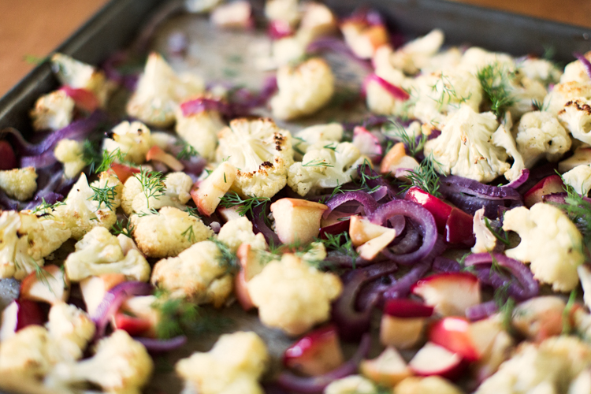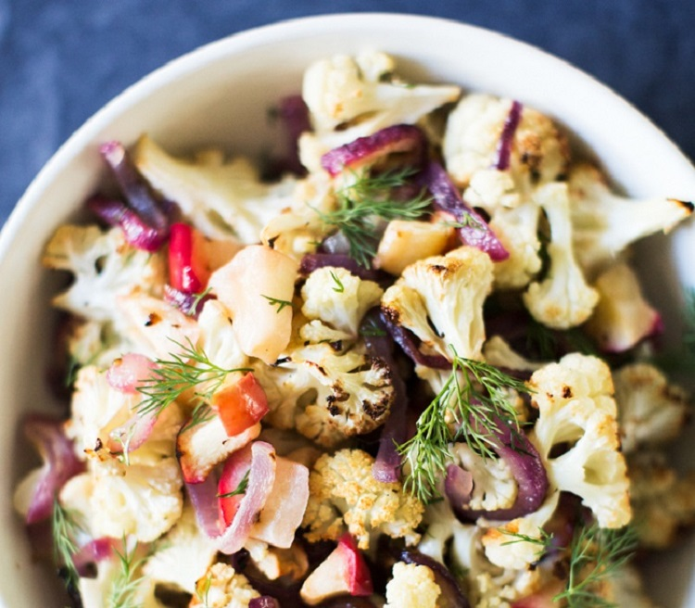

The magic of *roasted vegetables* was one of my favorite discoveries when we first started exploring cooking. I didn’t love raw cauliflower at the time, but roasted was a whole different matter: rich, almost buttery goodness that I couldn’t help myself from snitching off the roasting pan. Can roasted vegetables be considered a gateway drug to eating nutritious foods? Eating them is one of my earliest memories of realizing healthy foods can be utterly delicious (and for this reason, we talk a little about roasting vegetables in Episode 1 of our podcast).

This recipe is an old favorite of ours that we made for Thanksgiving 2011 (here’s the old recipe), with an updated photo and some slight tweaks. It came out just as flavorful as I remembered; sweet red onions and apples against the savory cauliflower, punctuated by the refreshing, aromatic fresh dill. It’s a family favorite, for sure. If you do try it, make sure to get a hold of some fresh dill; it will likely have to be store-bought since the growing season is over by now in Indiana, but it’s absolutely worth it for the splurge.

This side dish is the last in our Healthy Thanksgiving 2015 menu, where Alex and I create a veggie-filled menu to show that the holiday can be about seasonal, nutritious eating instead of stuffing ourselves with rich foods. We hope you’ve enjoyed our Thanksgiving menu, and we’d love to see and hear about what you’re planning to make this year! PS This is also a great recipe for anytime, so roast away all season!

serves: 4 to 6

### What you need

* 1 large cauliflower (2¼ pounds whole; 7 cups chopped)
* 1 large red onion
* 2 apples
* 2 tablespoons fresh dill (do not substitute dried)
* 3 tablespoons olive oil
* 1 teaspoon kosher salt
* Fresh ground black pepper

### What to do

1. Preheat oven to 450°F.
2. Remove the core of the cauliflower and chop it into florets. Slice 1 red onion. Core and chop 2 apples into bite-sized pieces (do not peel). Coarsely chop 2 tablespoons dill.
3. Place the cauliflower, red onion, and apples into a large bowl and mix together with 3 tablespoons olive oil, 1 teaspoon kosher salt and plenty of fresh ground pepper.
4. Line a baking sheet with parchment paper. Place the chopped vegetables on the baking sheet, then roast for 40 minutes until the cauliflower is slightly browned, stirring twice during the baking time. Remove from the oven, stir in the dill, and place in a serving dish. Serve immediately.

## Baked Pasta with Awesome Sauce

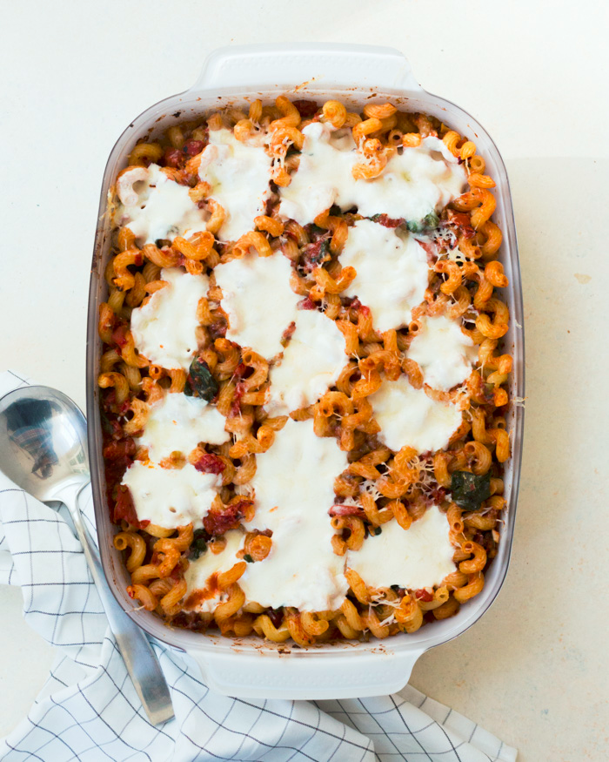

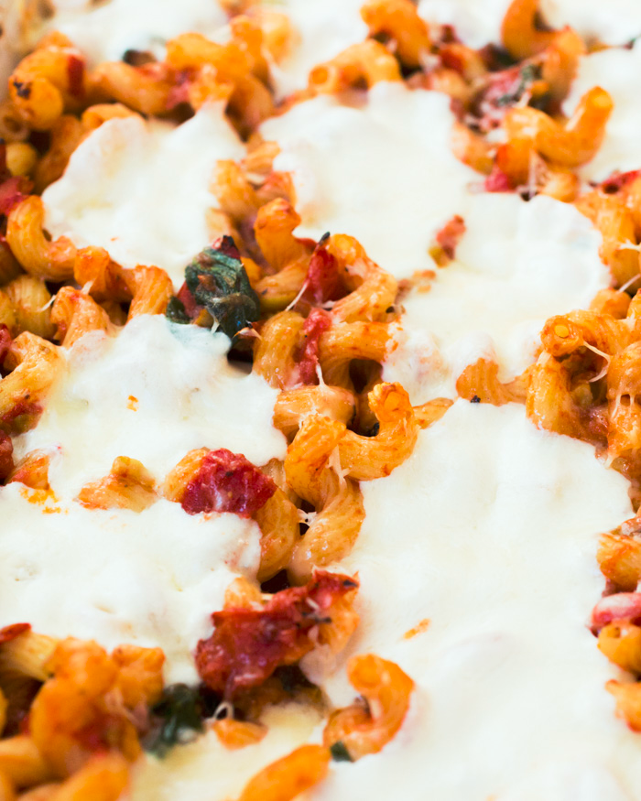

Serves: 6 to 8

### WHAT YOU NEED

* 1 pound cavatappi
* 4 garlic cloves
* 1 shallot
* 6-ounce dry weight can green olives (pitted)
* 2 tablespoons olive oil
* [1 28-ounce can Muir Glen Organic crushed tomatoes](http://www.muirglen.com/product/organic-fire-roasted-crushed-tomatoes-28oz/) (original or fire roasted)
* [1 15-ounce can Muir Glen Organic diced tomatoes](http://www.muirglen.com/product/organic-fire-roasted-diced-tomatoes-14-5oz/) (original or fire roasted)
* 1 tablespoon aged balsamic vinegar
* 2 tablespoon unsalted butter
* ¼ teaspoon ground nutmeg
* 2 teaspoons dried oregano
* 2 teaspoons dried basil
* 1 teaspoon red pepper flakes
* ½ teaspoon kosher salt
* ¼ teaspoon black pepper
* 1 teaspoon honey (optional)
* 4 cups baby spinach leaves
* 8 ounces fresh mozzarella cheese, sliced into disks
* ½ cup parmesan cheese, grated

### WHAT TO DO

1. Preheat oven to 425°F.
2. Boil 6 quarts water with 2 tablespoons kosher salt. Add the pasta and boil until al dente, about 6 to 7 minutes, then drain. Pour into a 9” x 13” pan and add a glug of olive oil to prevent it from sticking.
3. Peel and mince the garlic and shallot. Drain the olives and finely chop them.
4. In a large saucepan, heat the olive oil over medium heat. Add garlic and shallot and cook gently for 2 to 3 minutes until fragrant. Add the olives, tomatoes and their juices, balsamic vinegar, butter, nutmeg, oregano, basil, red pepper flakes, kosher salt, pepper, and honey and stir to combine. Simmer gently for 15 minutes. Taste and adjust salt as desired. Add the spinach leaves and cook another 2 to 3 minutes until tender.
5. Pour the sauce into the pasta in the baking dish and mix to combine. Top with slices of fresh mozzarella cheese and grated parmesan cheese. Bake until the cheese is golden, about 15 minutes. Allow to cool slightly before serving.

# Category: Breakfast

## Cornbread Waffles with Maple Mascarpone Schmear

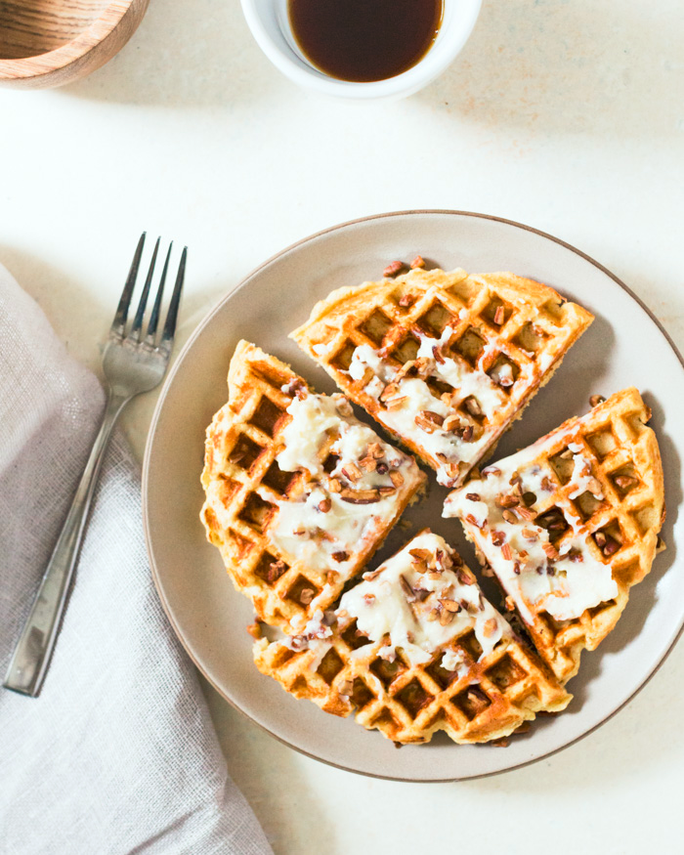

Mornings for us revolve around [coffee](http://www.acouplecooks.com/how-to-make-coffee-with-an-aeropress/), [coffee](http://www.acouplecooks.com/podcast/16-for-coffee-lovers-only/), and more coffee. On most days, breakfast is supremely simple fare. But on special occasions or with guests, we’re inching towards becoming people who breakfast. Funny story: we didn’t own a waffle maker until last year, after we had this lazy morning [waffle brunch](http://www.acouplecooks.com/waffle-party/) with our pal [Ashley](http://www.edibleperspective.com/). Ashley is 1000% passionate about breakfast, and after that meal we were convinced making space in our cupboard for a waffle maker would be absolutely worth it. That trip was the first time Alex and I had met Ashley in “real life” after knowing her for years online. We originally bonded over food and photography, and over time the three of us grew to be fast friends though we were states apart.

So it seems only fitting to honor the breakfast queen with a waffle recipe, as she is pregnant with her first little one due in December! These cornbread waffles with maple mascarpone are a mixup of Ashley’s [cornmeal waffles](http://www.edibleperspective.com/home/2013/6/6/breakfast-friday-cornbread-waffles.html) and our [maple mascarpone](http://www.acouplecooks.com/pumpkin-pancakes-maple-mascarpone-gluten-free/). We loved the dense texture and complex flavor of these gluten-free waffles, set off by the fluffy sweet mascarpone cheese topping. It started out as a dollop on top, but ended up with a messy schmear, which seemed absolutely appropriate.

We’ve banded together with some additional friends from around the internet to celebrate Ashley in a virtual breakfast-themed event today. See below for the full list of recipes, and check the Instagram hashtag #ediblebabybash for more breakfast ideas!

Ashley, we are over the moon happy for you and know you will be the most amazing mama! It has been a thrill to walk with you through this process and we can’t wait to meet your sweet babe! Sending so much love.

Serves: 2

### WHAT YOU NEED

* ½ cup mascarpone cheese (or cream cheese)
* 3½ tablespoons maple syrup
* ½ cup masa harina
* ¼ cup fine or medium ground cornmeal
* ¼ cup gluten-free oat flour*
* 1 teaspoon baking powder
* ½ teaspoon kosher salt
* 1 large egg
* ¾ cup milk (or almond milk)
* 2 tablespoons butter (or coconut oil), melted and cooled
* Chopped pecans, for serving
* *You can grind your own oat flour by processing rolled oats in a food processor or high-speed blender.

### WHAT TO DO

1. Preheat a waffle maker to medium high heat; grease it if necessary.
2. In a small bowl, mix together 2 tablespoons maple and the mascarpone, then set aside.
3. In a large bowl, mix together the masa harina, cornmeal, oat flour, baking powder and kosher salt.
4. In a medium bowl, whisk the egg, then whisk in the milk, melted butter, and 1½ tablespoons maple syrup. Pour the wet ingredients into the dry ingredients and mix until just combined.
5. Let sit undisturbed for 7 minutes. After sitting, the batter becomes very thick and unpourable.
6. Scoop half of the batter onto the heated waffle maker and gently spread it into an even with a spatula. Cook until golden brown. (The resulting waffle will be golden brown and soft, but it will firm up a bit as it cools. If the waffle maker is too hot, this may prevent the inside from cooking fully). Serve immediately with maple mascarpone.
7. To store leftovers, let cool fully and freeze in an airtight plastic bag; reheat in a toaster or oven.

## 

## Parmesan Herb Baked Eggs

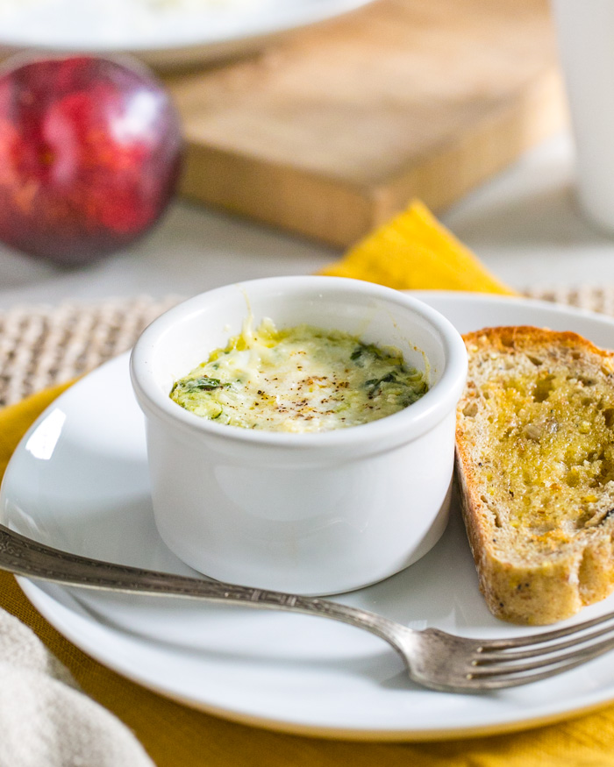

Our last recipe to share with you this year is a special little breakfast dish, made first for us by our dear friend Lindsay during a visit to Minnesota. She whipped up these baked eggs with Parmesan, some fresh herbs, and a little cream, and we were smitten. We immediately had to give them a try, and have enjoyed them since then as special breakfasts when we’re entertaining, most recently with our sweet niece and nephew visiting from Arizona.  
  
It takes a just a bit of prep time to throw together in the morning, but mincing the shallot and herbs the night before it makes for an easy assembly. The key is removing from the oven when the egg whites are just set, but the yolk is still runny. Spread on some crunchy toast, it’s quite the treat! It would be a great New Year’s brunch option.  
  
And with that, 2013 comes to a close. Have you been pondering the highs and lows of this past year? Making compilation videos of your Instagram snapshots? Alex and I are eternal optimists and generally rate every year as a two-thumbs-up, but this year has been a little crazier than most. We’re looking forward to a fresh start in 2014 — cheers to the New Year! We can’t wait to share new recipes and inspiration in the coming year.  
  
Have a safe and happy new year!

Serves: 4

### WHAT YOU NEED

* 1 large shallot
* 1 tablespoon fresh rosemary (chopped)
* 1 tablespoon fresh thyme (chopped)
* 2 tablespoons butter, divided
* ½ teaspoon oil
* 8 eggs
* ¼ cup milk (or cream)
* ¼ cup freshly grated Parmesan cheese
* Kosher salt
* Fresh ground black pepper

### WHAT TO DO

1. Preheat the oven to 375°F.
2. Mince the shallot. Remove the leaves from the thyme and rosemary, then finely chop them.
3. In a small saucepan, heat ½ tablespoon butter and ½ tablespoon olive oil at medium high. Add the shallot and saute until soft and fragrant, about 3 to 5 minutes. Turn off the heat, add the herbs and salt, and stir to combine.
4. In the bottom of each of 4 ramekins, place a small pat of butter (about 1 teaspoon). Set the ramekins on baking sheet and place the tray in oven for a few minutes until butter is melted.
5. Remove ramekins from oven, add 1 tablespoon of milk to each, and crack 2 eggs into each ramekin without breaking the yolk. Sprinkle the herb mixture over the top of each ramekin and return to the oven. Bake for about 7 minutes.
6. Turn up the heat to the high broil setting and broil the eggs for another 3 to 4 minutes. Remove from the oven when egg whites are just set and yolks are still soft. Top each with 1 tablespoon Parmesan cheese; season with kosher salt and fresh ground black pepper. Let stand for about 5 minutes until the cheese is melted.

# Category: Salads

## Superfood Salad

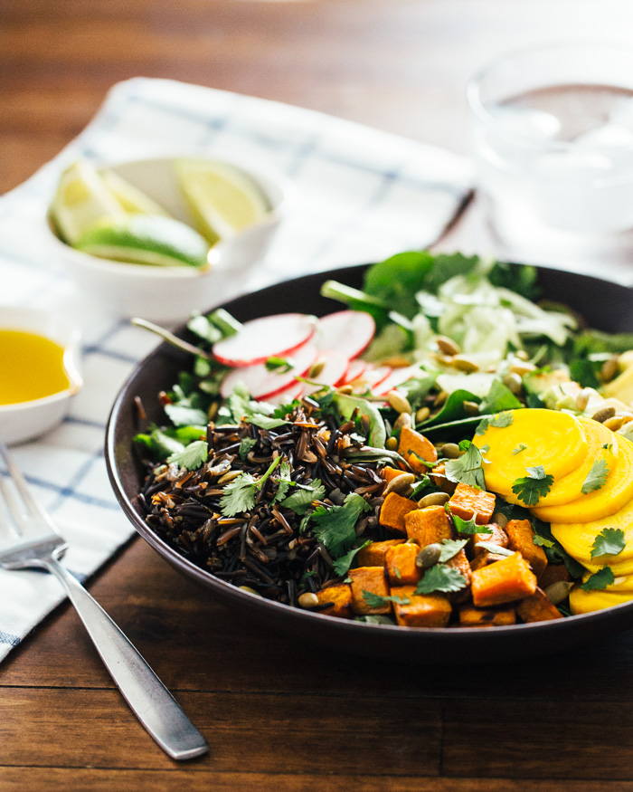

Ready for another knock-out salad? Our friend Emily over at Models for Wellness approached us for a collaboration about healthy and whole eating. Models for Wellness is a group of models in NYC who came together to inspire holistic changes in people’s diets and lives. Says Emily, “We’re on a mission to change the way people think about body image. We want people look up to models as role models in health, instead of dieting and going down the wrong path to achieve the ‘ideal’ body image that society makes even us models believe we need to achieve.”  
  
We love that message, and we had Emily share one of her favorite recipes with us, this superfood salad. Not only is she gorgeous and positively glowing, she’s got fabulous taste for nourishing food. This salad is satisfying enough to eat it for dinner, and perfect for taking leftovers to work. It’s similar to our nourish bowl, but we love that the dressing is super simple: a squeeze of lime juice and drizzle of olive oil. We hope you love it as much as we did! Check out Emily’s description of the salad below:

Serves: 1

### WHAT YOU NEED

* 1 large sweet potato
* ½ cup cooked wild rice
* 1 raw beet
* 2 radishes
* ¼ cup shredded cucumber
* ½ avocado
* 2 tablespoons chopped cilantro
* 1 handful spinach
* 1 handful mixed greens
* 1 lime
* 1 tablespoon olive oil
* 1 tablespoon pepitas

### WHAT TO DO

1. Preheat oven to 450°F.
2. Dice 1 large sweet potato; place it in a bowl and mix with enough olive oil to coat, a sprinkle of kosher salt, and fresh ground pepper. Line a baking sheet with parchment paper and place the potatoes onto the sheet; roast until tender, about 25 minutes.
3. Meanwhile, prepare the wild rice according to the package instructions.
4. Peel and thinly slice the beet. Thinly slice 2 radishes. Peel and grate ¼ cup cucumber. Slice ½ avocado. Chop 2 tablespoons cilantro.
5. To serve, place the salad greens and spinach in a bowl. Arrange small piles of each vegetable and the rice. Drizzle with the juice of 1 lime and 1 tablespoon olive oil. Top with sunflower seeds or peptias.

## Mediterranean Bulgur Salad (Tabbouleh)

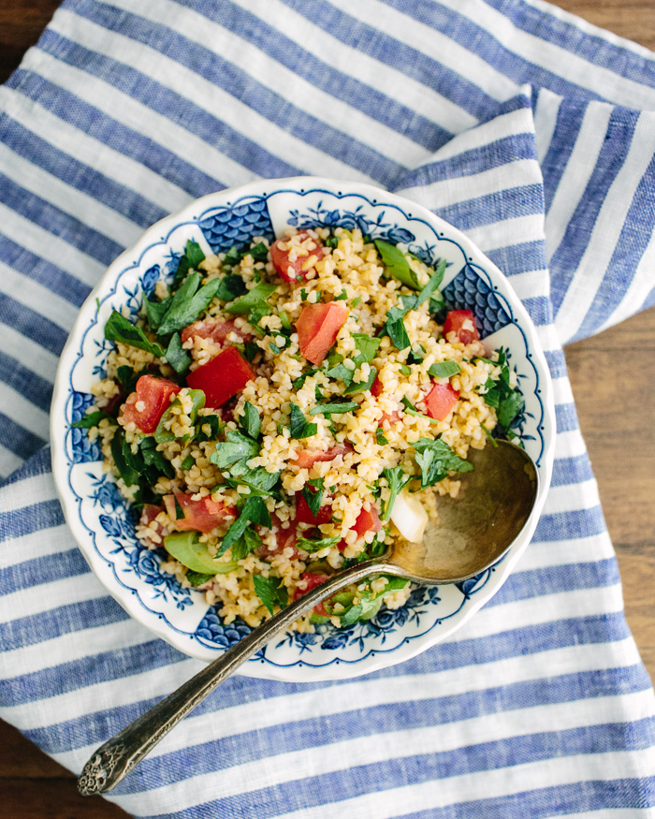

We had a bulgur salad similar to this one on our recent trip to [Greece](http://www.acouplecooks.com/2014/06/santorini-greece/). There was a breathtaking sunset over the Mediterranean, and we had just ordered a list of small plates so large that the server looked at us like we were crazy. With my husband and sister on my right and my best childhood friend and her fiance on my left, it was like one of those “happy place” daydreams where all your favorite people who live on different continents converge together in some gorgeous island destination.

It’s now a distant memory (sigh!), but we still have that salad. It was made a bit differently and called “pligouri” (bulgur wheat) salad, but this rendition is close. Since it’s very similar to tabbouleh, we’ve labeled it as such — though tabbouleh actually originates further East across the Mediterranean.

This is a fabulous summer salad since it’s easy to put together and deliciously light and herby. We love the fact that the bulgur wheat makes this dish “no cook” – just pour boiling water over the bulgur and let it sit for 30 minutes (it seems like magic each time we do it!). Bulgur wheat is a quick-cooking whole grain that you should be able to find at most supermarkets. The salad is another great option, along with this [Greek Salad](http://www.acouplecooks.com/2014/06/greek-salad/), to bring to a summer picnic or barbecue (perhaps July 4, if you’re in the US!).

Serves: 4 to 6

### WHAT YOU NEED

* 1 teaspoon kosher salt
* 1 ½ cups bulgur wheat
* 4 medium tomatoes (enough for 2 cups chopped)
* 3 green onions
* 1 clove garlic
* 2 cups fresh parsley (one large bunch)
* ¼ cup mint
* 2 lemons
* 5 tablespoons olive oil
* Fresh ground pepper

### WHAT TO DO

1. Add 1 teaspoon kosher salt to 1 ½ cups water and bring it to a boil. Place 1½ cups bulgur wheat in a bowl and pour over the boiling salted water. Let sit for 30 minutes.
2. Meanwhile, core 4 medium tomatoes and remove the seeds; finely dice the remaining flesh. Dice 3 green onions and mince 1 clove garlic. Chop 2 cups fresh parsley and ¼ cup fresh mint. Zest 1 lemon.
3. When the bulgur is finished, fluff it with a fork. Add tomatoes, green onions, garlic, parsley, mint, lemon zest, 5 tablespoons olive oil, juice of 2 lemons, a few pinches kosher salt, and fresh ground pepper. Stir gently to combine. Serve with additional lemon wedges.

# Category: Desserts



## Peppermint Meringues

If you’re looking for a healthier cookie this holiday season, these peppermint meringues have a leg up since the main ingredient has zero calories: air! They’re made simply of egg whites and sugar whipped with air until they become a fluffy cloud of goodness. And at about 15 calories a pop, they’re one of the lightest cookie recipes we’ve made.

Each holiday season, Alex and I develop a few sweets that are on the lighter side but are just as delicious as their heavier counterparts. (We also talk about a few ideas on our latest podcast to launch December 7, and even [call a friend](http://cookieandkate.com/) to get her favorite ideas.) It can be difficult to strike a balance with sugar in the holiday season, so our coping mechanisms are simple: focus on homemade recipes with real ingredients, and eat in moderation when possible. (Here’s a post on [9 tips for eating in moderation](https://www.acouplecooks.com/9-tips-for-eating-in-moderation/) I wrote a while back.)

While these meringues seem light and carefree, they do take a bit of concentration to pull off. It took us a failed batch to realize the importance painting neat lines into the bottom of a pastry bag (paint them up too far and half of the batch is white; paint them too messy and the red isn’t dark enough). If you’re up for the challenge, make sure you have a paintbrush, pastry bag, and some red gel food coloring. With a steady hand, they’re a fun holiday challenge.

Serves: About 45

### WHAT YOU NEED

* 3 large egg whites
* ¾ cup granulated sugar
* ¼ teaspoon cream of tartar
* 1 pinch kosher salt
* ⅛ teaspoon peppermint extract
* Red gel food coloring
* Pastry bag and small art paintbrush

### WHAT TO DO

1. Preheat oven to 250°F.
2. Fill a saucepan with water and heat to a low simmer, but not boiling. In the bowl of a stand mixer, combine egg whites, sugar, cream of tartar, and salt. Lower the bowl into the simmering water and stir until the sugar is dissolved and the mixture is fluffy, about 3 minutes.
3. Place the bowl under the mixer, then whisk on high for 8 to 10 minutes until stiff peaks form. Once there are stiff peaks, turn off the mixer and add peppermint extract. Whisk on low for about 30 seconds to fully incorporate.
4. Meanwhile, fit a large circle tip on a plastic pastry bag and neatly fold down the top 6 inches of the bag to form a sturdy cone. For stability, place the bag tip-down in a pitcher. Squeeze some red gel food coloring on a plate and carefully paint a ½ inch wide stripe from the tip to where the bag is folded. Repeat with 3 more lines, evenly spaced. Be careful not to smudge the lines.
5. After the stripes are painted, carefully add spoonfuls of meringue into the center of the pastry bag. Pipe small swirly cones, about 1½ inches wide onto two parchment lined baking sheets. Each one will be a little unique, so enjoy the process!
6. Bake for 1 hour, then turn off the oven, let out a bit of the warm air, then leave in the oven for another 90 minutes for the insides to dry. Store in a covered container for several days.

## Dark Chocolate Cherry Quinoa Bark (Gluten-Free)

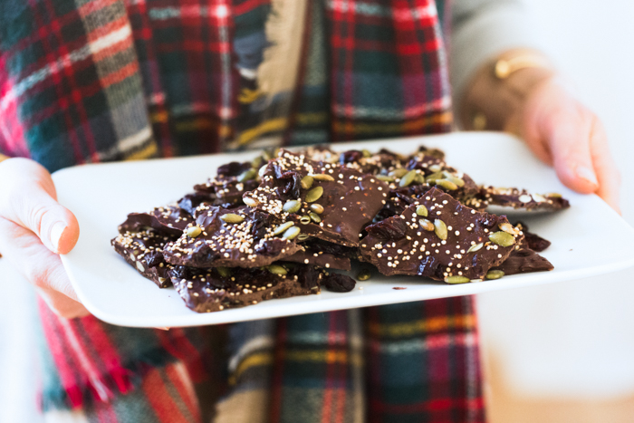

The holiday season has never naturally been my forte. Decorations are not my thing, nor is baking. It took me well into my adult years to get my own (artificial) Christmas tree, and some years we don’t even put it up (I know, I know!). Usually we travel back to my home state of Minnesota during the holidays, so I’m generally a consumer of that cozy holiday atmosphere, not a creator of it.

As each year goes by, though, Alex and I are starting to find what feels natural to us: giving homemade or experience gifts with my side of the family, exchanging donations with my sister. Doing no gifts at all with my best friends, opting for time together. Snuggling under blankets with hot tea next to the Christmas tree, decorated with our nieces and nephews. [Baking Christmas tree pizzas](http://www.acouplecooks.com/2015/12/pesto-christmas-tree-pizza-recipe/). Making super simple holiday treats.

This dark chocolate bark is a holiday treat that feels just right in its simplicity. It’s so delicious and easy to make that can’t believe we’ve never tried it before, especially around the holidays (though it is similar to [these](http://www.acouplecooks.com/2013/12/dark-chocolate-pistachio-cranberry-clusters/)). It’s also gluten-free and could be made vegan with vegan chocolate, making it a versatile treat for family and friends of various diets. In terms of toppings, this combination is top-notch: Montmorency (it’s a variety) tart cherries, salty pumpkin seeds, and roasted quinoa for some added crunch. I hesitate to call it a healthy Christmas treat only because the word healthy can connote a sacrifice of taste, and this is anything but. When something can combine both fantastic flavor and nutrients (as tart cherries, seeds, and dark chocolate do), it’s a favorite in our house. I know we’ll be making this for years to come. It’s also a fantastic homemade holiday gift! Let us know if you give it a try.

### WHAT YOU NEED

* 3 tablespoons quinoa
* ½ cup dried tart cherries
* 12 ounces (2 cups) dark chocolate chips
* ¼ cup plus 2 tablespoons roasted salted pepitas (pumpkin seeds)

### WHAT TO DO

1. Toast the quinoa over medium low heat in a dry pan for 3 to 5 minutes, shaking the pan often, until golden (some kernels will pop during the process). Remove from heat into a bowl to cool fully.
2. Chop the dried cherries.
3. Fill a large skillet halfway with water and bring to a simmer. Place chocolate in a heat-safe bowl (metal or glass). Once the water is simmering, turn off the heat and place the bowl of chocolate in the water, then stir until melted. (Alternatively, melt in a microwave for 30-second intervals until melted and smooth, stirring in between each interval with a spatula). When chocolate is fully melted, stir in 2 tablespoons quinoa, ¼ cup cherries, and ¼ cup pepitas.
4. Line a baking sheet with parchment paper. Using a spatula, spread the chocolate mixture over the parchment paper in a ¼-inch thick layer. Sprinkle over the top the remaining 1 tablespoon quinoa, ¼ cup cherries, and 2 tablespoons pepitas.
5. Refrigerate at least 15 minutes until hardened. When hard, cut into irregular pieces with a knife. Store in an airtight container at room temperature for up to 4 days or refrigerated for up to 2 weeks.